MILLENIUM BRIDGE

BRIDGE

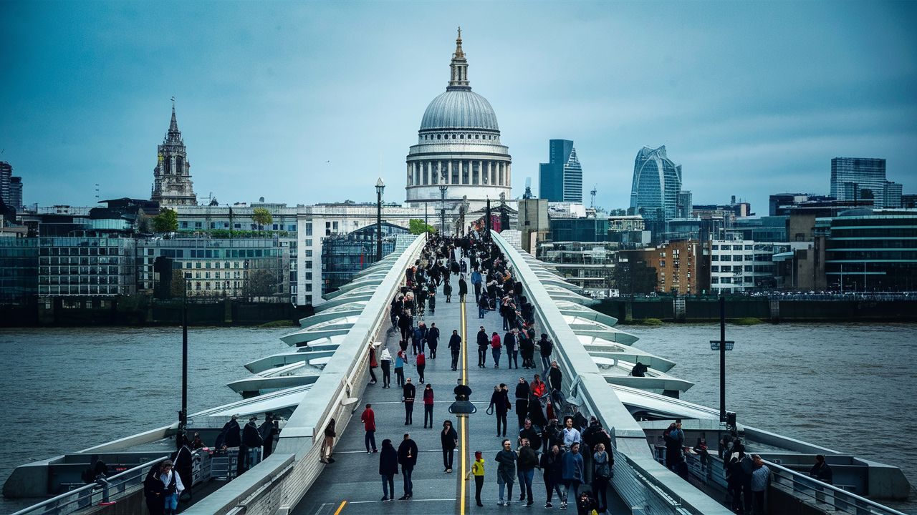
The Millennium Bridge, an architectural wonder spanning the River Thames in London, stands as an iconic symbol of modernity and innovation. Designed by Foster and Partners in collaboration with sculptor Sir Anthony Caro, this pedestrian suspension bridge was opened to the public in June 2000 to mark the turn of the millennium. Its sleek, minimalist design features a sinuous steel deck supported by a pair of elegant suspension cables, creating a striking visual contrast against the historic backdrop of London's skyline.As pedestrians traverse the Millennium Bridge, they are treated to unparalleled views of the cityscape, with landmarks such as St. Paul's Cathedral and the Tate Modern Museum framing the horizon. The bridge's slender profile and transparent glass balustrades offer unobstructed vistas of the River Thames below, inviting contemplation and reflection as one moves gracefully across its span.Yet, the Millennium Bridge is more than just a feat of engineering and design; it is a cultural icon that has captured the imagination of people around the world. Its inauguration was celebrated with great fanfare, drawing crowds of visitors eager to experience the thrill of walking across a bridge suspended over the river's waters. However, shortly after its opening, an unexpected phenomenon known as "synchronous lateral excitation" caused the bridge to sway uncomfortably under the weight of pedestrian traffic, leading to its temporary closure for modifications

